**Placement Questions**

**Capgemini**

1. What will be the output if limit = 6?  
     
   Read limit  
   n1 = 0, n2= 1, n3=1, count = 1;  
   while count <= limit  
   count=count+1  
   print n3  
   n3 = n1 + n2  
   n1 = n2  
   n2 = n3  
   End While

a)112358

b)12358

c)123581321

d)12358132

Answer :

Option a

First iteration of while loop: count <= limit. 1<=6. So, we will enter while loop.

count=2

Now we will print n3. So value of n3 is 1. 1 will be printed.

n3=n1+n2. So, n3=1,n1=1,n2=1  
 Second iteration: Count=3, Print n3. So 1 will be printed , n3=2, n1=1, n2=2  
 Third iteration: Count=4, Print n3. So 2 will be printed , n3=3, n1=2,  n2=3  
 Fourth iteration: Count=5 , Print 3, n3=5, n1=3, n2=5  
 Fifth iteration: Count=6, Print 5, n3=8, n1=5, n2=8  
 Sixth iteration: Count=7, Print 8, n3=13, n1=8, n2=13  
 Hence output will be 112358

2. What is the output of the following pseudocode for a=3, b=8, c=7 ?

Integer funn(integer a,integer b, integer c)

if ((a^8) < 8)

c=a+c

c=a+c

End If

Return a+b+c

a)18

b)12

c)23

d)29

Answer: a)18

a=3 (0011) 8(1000)

a^8 - 0011

1000

1011

a^8 < 8 -> 11<8 -> False

So, a+b+c = 3+8+7 = 18 will be printed

3. What will be the space required for this piece of code?

int sum (int B[], int n)  
{  
 int s = 0, j;  
 for (j = 0; j < n; j++)  
 s = s + B[i];  
 return s;  
}// sizeof(int) = 2 bytes

a)2n+8

b)2n+4

c)2n

d)2n+2

Answer:

a) 2n+8

There are n elements in the array and the int data type acquires 2 bytes, so there will be 2n bytes acquired.  
The int array occupies 4 bytes.  
The s variable will occupy 2 bytes.  
The j variable will occupy 2 bytes.  
So total=2n+4+2+2=2n+8 bytes.

4. What is the output of the following code?

Character *ptr

Set *ptr= ‘Pointers’

Print *&*&*ptr

a)Segmentation fault

b)P

c)Compiler error

d)Pointers

Answer:

b)P

* - Dereferencing pointer

& - Referencing pointer

Both cancel out each other and print the output as ‘P’

5. Which of the following permutations can be obtained in the output using a stack assuming that the input is in the sequence 1, 2, 3, 4, 5 in that order?

a) 3, 4, 5, 1, 2

b) 3, 4, 5, 2, 1

c)1, 5, 2, 3, 4

d)5, 4, 3, 1, 2

Answer:

b) 3, 4, 5, 2, 1

In a stack, first 1 and 2 are pushed. Then 3 is pushed and popped from the stack. Then 4 is pushed and popped and then 5. 1 and 2 are popped from the stack which will be permutation obtained.

6. Evaluate the postfix expression:

12+3*42-31+*-

a) 3

b) 1

c) 0

d) 2

Answer:

b) 1

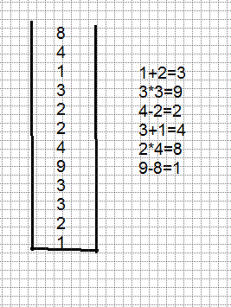

7. Which of the data structures can have more than one logical way of traversing ?

a) Arrays

b) Linked list

c) Queue

d) Tree

Answer: d) Tree

Tree can be traversed by BFS, DFS, Inorder, Preorder, Postorder.

8. Which of the following is true concerning the directed graph shown below?

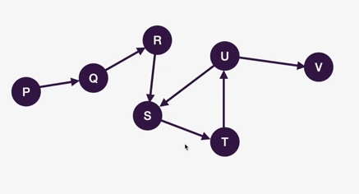

a)Only two topological orderings are possible

b)Only one topological ordering is possible

c)More than two topological orderings are possible

d) No topological ordering is possible

Answer:

d) No topological ordering is possible

Topological ordering can be calculated for only directed acyclic graphs. So the given graph is a cyclic graph and no topological ordering is possible for the given graph.

9. What will be the output of the following pseudocode for input a = 30, b = 60, C = 90?

Integer a, b, c, sum

Read a, b, c

Set sum = a + b + c

if ((sum EQUALS 180) and (a NOT EQUALS 0) and (b NOT EQUALS 0) and (c NOT EQUALS 0))

Print " Success"

Otherwise

Print "Fail"

End if

a)Success b)Fail

c)Compilation error d)None of the above

Answer:

a)Success

a = 30, b = 60, C = 90sum=180((sum EQUALS 180) and (a NOT EQUALS 0) and (b NOT EQUALS 0) and (c NOT EQUALS 0))

So, (true) and (true) and (true) and (true)

So, output will be "success"

10. What will be the output?

#include <iostream>

using namespace std;

int main()

{

int a = 32, *ptr = &a;

char ch = 'A', &cho = ch;

cho += a; *ptr += ch;

cout << a << ", " << ch << endl;

return 0;

}

a)129,a b)32,A c)129,A d)32,a

Answer: 129,a

The “ptr” variable is a pointer which holds the address of variable “a”. And “*ptr” returns the value of “a” variable. “cho” is a reference variable to “ch”. So any change made to “cho” will be reflected to “ch”. As such, when “cho” is increased by 32, it adds to the ASCII value of “A”(which is 65), and this results to 97 which is the ASCII value of “a”(from the alphabet). So this “a” gets stored in “ch”. As for when “*ptr” is incremented by “ch”, it gives value 97+32=129

11. Find the missing value in the grid.

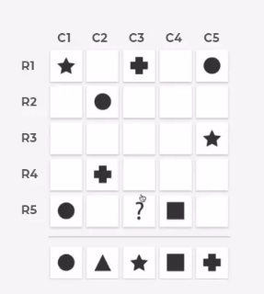

Answer:

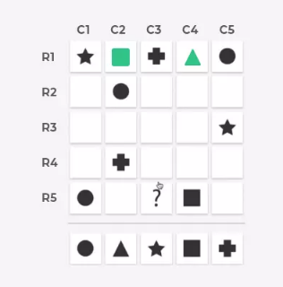

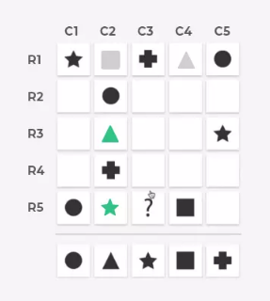

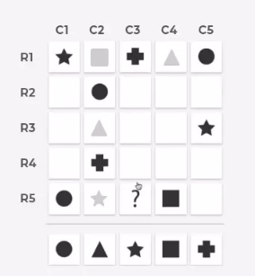

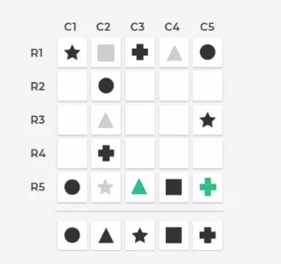

12. The below two grid follows a rule. Find the set of grid

that follows the rule.

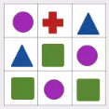

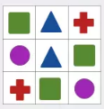

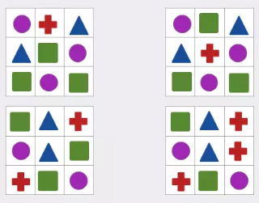

Answer: 1 and 3

13. Put the red ball into the hole in minimum number of steps

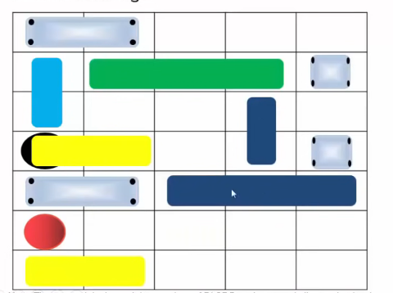

Answer:

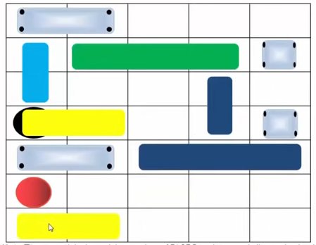

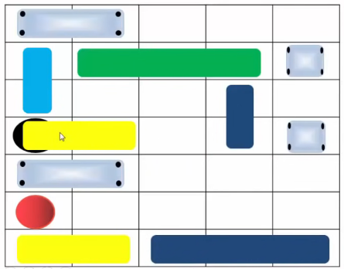

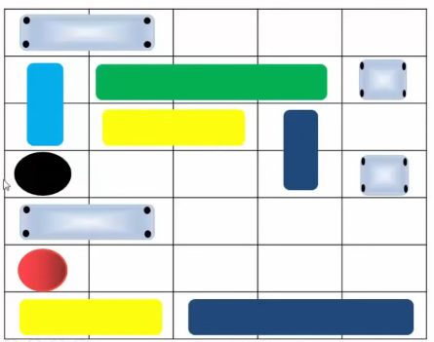

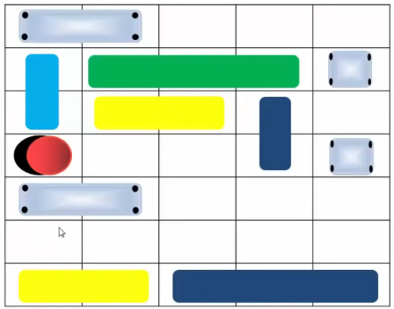

14. In this challenge, a grid with many coordinates will be shown with a point highlighted and then two figures.

* First remember the highlighted grid position
* Simultaneously, mark if the next two shown figures are symmetrical or not
* At the end mark all the highlighted grid in last slide

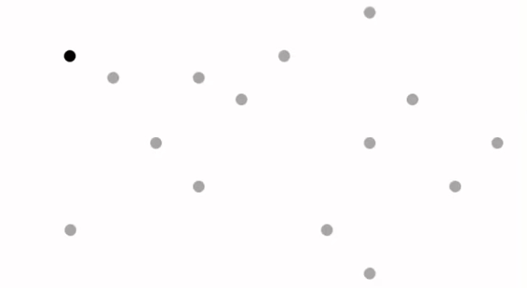

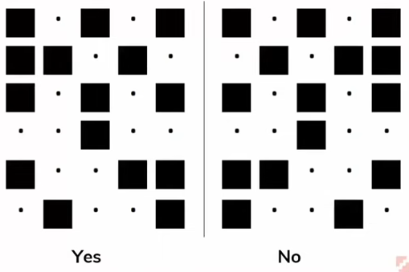

Answer : Yes

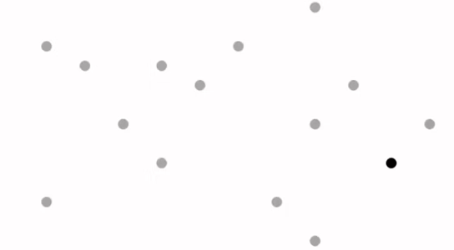

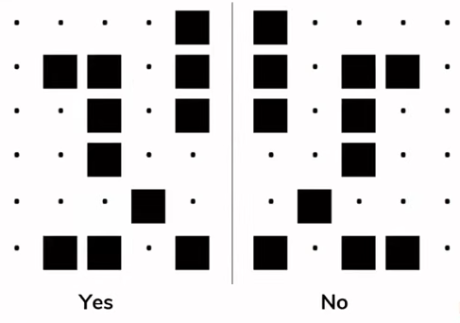

Answer : Yes

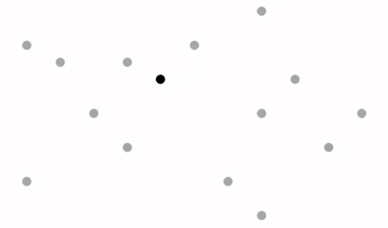

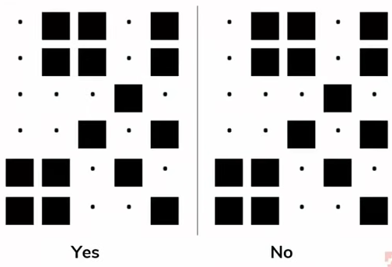

Answer: No

Now mark the points in order,

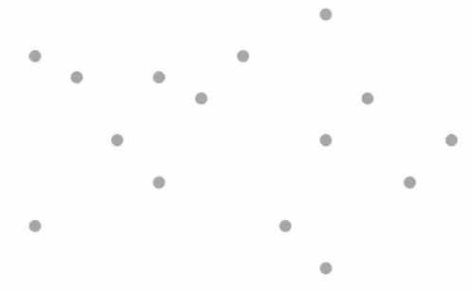

Answer:

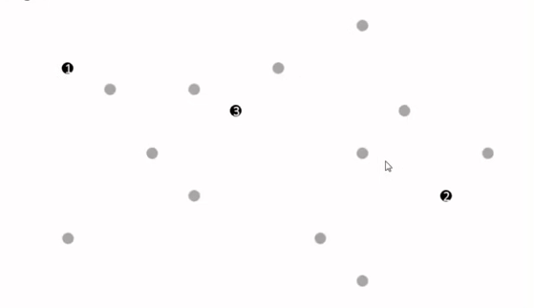

15. Behavioral Competency questions

I.

1. I generally do not misplace things.

2. I am very organised

II.

1. I like to summarize everything at the end of the meeting

2. I like to write down points simultaneously while having a meeting

a)Agree b)Slightly disagree

c)Slightly disagree d)Disagree

16. Find the maximum & minimum of two numbers in a single line without using any condition & loop.

Answer:

void main ()

{

int a=15, b=10;

printf (“ max = %d, min = %d”, ((a+b) + abs(a-b)) /2, ((a+b) – abs (a-b)) /2);

}

17. Write a program to print 100 times “Hello” without using loop & goto statement.

Answer:

void main()

{

show (1, 100);

}

show (int x, int y)

{

if (x>=y)

return;

printf (“\n Hello”);

show (x+1, y);

}

18. Write a program to check for equality of two numbers without using arithmetic or comparison operator

Answer:

#include<iostream>

using namespace std;

int main(){

int a = 132;

int b = 132;

if ( (a ^ b) )

cout<<"a is not equal to b";

else

cout<<"a is else to b";

return 0;

}

19. Write different ways to swap the given numbers

i. Using temporary variable

#include <stdio.h>

void main()

{

int x=10, y=20, temp;

printf("Before Swapping\n x = %d\n y = %d\n", x, y);

temp = x;

x = y;

y = temp;

printf("After Swapping\n x = %d\n y = %d\n", x, y);

}

ii. Without using temporary variable

#include <stdio.h>

void main()

{

int x=10, y=20;

printf("Before Swapping\n x = %d\n y = %d\n", x, y);

x=x+y;

y=x-y;

x=x-y;

printf("After Swapping\n x = %d\n y = %d\n", x, y);

}

iii. Using bitwise XOR operator

#include <stdio.h>

void main()

{

int x=10, y=20;

printf("Before Swapping\n x = %d\n y = %d\n", x, y);

x=x^y;

y=x^y;

x=x^y;

printf("After Swapping\n x = %d\n y = %d\n", x, y);

}

iv. Using pointer

#include <stdio.h>

void main()

{

int x=10, y=20,*ptr1,*ptr2,temp;;

printf("Before Swapping\n x = %d\n y = %d\n", x, y);

ptr1 = &x;

ptr2 = &y;

temp = *ptr2;

*ptr2 = *ptr1;

*ptr1 = temp;

printf("After Swapping\n x = %d\n y = %d\n", x, y);

}

v. Using user defined function

#include <stdio.h>

void swap(int*, int*); //function declaration

void main()

{

int x=10, y=20;

printf("Before Swapping\nx = %d y = %d\n", x, y);

swap(&x, &y); //function call

printf("After Swapping\nx = %d y = %d\n", x, y);

}

//function definition

void swap(int *ptr1, int *ptr2)

{

int temp;

temp = *ptr2;

*ptr2 = *ptr1;

*ptr1 = temp;

}